Interoperability for web portrayal services : a use case with deegree3

Setting up a deegree3 workspace
- creation of a FeatureStore connected to a shapefile : <ShapeFeatureStore>
  - let's say the shapefiles are in the DEEGREE_WORKSPACE_ROOT/data directory
  - we create the meteocities.xml file in a DEEGREE_WORKSPACE_ROOT/datasources/feature directory
  - the FeatureStore is now identified by its filename meteocities
<ShapeFeatureStore xmlns="http://www.deegree.org/datasource/feature/shape"
xmlns:xsi="http://www.w3.org/2001/XMLSchema-instance" configVersion="3.1.0"
xsi:schemaLocation="http://www.deegree.org/datasource/feature/shape http://schemas.deegree.org/datasource/feature/shape/3.1.0/shape.xsd">
<StorageCRS>EPSG:21781</StorageCRS>
<File>../../data/meteo/meteocities</File>
</ShapeFeatureStore>
- creation of a FeatureLayers linked to our meteocities FeatureStore
  - we create the meteocitiesLyr.xml file in DEEGREE_WORKSPACE_ROOT/layers directory
  - the FeatureLayers is now identified by its filename meteocitiesLyr
  - it binds meteocities FeatureStore to a layer named meteocities
  - other options here : FeatureType, Filter
<FeatureLayers xmlns="http://www.deegree.org/layers/feature"
xmlns:d="http://www.deegree.org/metadata/description" xmlns:l="http://www.deegree.org/layers/base"
xmlns:s="http://www.deegree.org/metadata/spatial"
xmlns:xsi="http://www.w3.org/2001/XMLSchema-instance"
xsi:schemaLocation="http://www.deegree.org/layers/feature http://schemas.deegree.org/layers/feature/3.2.0/feature.xsd"
configVersion="3.2.0">
<FeatureStoreId>meteocities</FeatureStoreId>
<FeatureLayer>
<l:Name>meteocities</l:Name>
<d:Title>Cities from switzerland with weather information</d:Title>
</FeatureLayer>
</FeatureLayers>
- creation of themes defining a tree of layers
  - we create the meteosuisse.xml file in DEEGREE_WORKSPACE_ROOT/themes directory
  - the tree is linked to one or many FeatureLayers by FeatureStoreId (filename above)
  - each theme has an identifier that identifies the layer name displayed by the GetCapabilities operation
  - these themes are identified by the filename meteosuisse
<Themes xmlns="http://www.deegree.org/themes/standard"
xmlns:d="http://www.deegree.org/metadata/description"
xmlns:s="http://www.deegree.org/metadata/spatial"
xmlns:xsi="http://www.w3.org/2001/XMLSchema-instance" configVersion="3.2.0"
xsi:schemaLocation="http://www.deegree.org/themes/standard http://schemas.deegree.org/themes/3.2.0/themes.xsd">
<LayerStoreId>meteocitiesLyr</LayerStoreId>
<Theme>
<d:Title>Meteosuisse theme</d:Title>
<Theme>
<Identifier>meteocities</Identifier>
<d:Title>Meteosuisse cities</d:Title>
<Layer>meteocities</Layer>
</Theme>
</Theme>
</Themes>
- creation of a deegreeWMS configuration
  - we create the mywms.xml file in DEEGREE_WORKSPACE_ROOT/services directory
  - it is linked to one themes file
<wms:deegreeWMS xmlns:wms="http://www.deegree.org/services/wms"
xmlns:xlink="http://www.w3.org/1999/xlink" xmlns:dgws="http://www.deegree.org/webservices"
xmlns:xsi="http://www.w3.org/2001/XMLSchema-instance" configVersion="3.2.0"
xsi:schemaLocation="http://www.deegree.org/services/wms http://schemas.deegree.org/services/wms/3.2.0/wms_configuration.xsd">
<wms:ServiceConfiguration>
<wms:ThemeId>meteosuisse</wms:ThemeId>
</wms:ServiceConfiguration>
</wms:deegreeWMS>
- let's test the WMS service ...
  - may be you have to reload your active workspace from the deegree console
  - test a GetCapabilites operation : http://localhost:8080/services/mywms?service=WMS&request=GetCapabilities
  - the response shows the root Layer titled Meteosuisse theme and its concrete child Layer named meteocities on which we can now request a GetMap
  - test a GetMap operation on meteocities : http://localhost:8080/services?SERVICE=WMS&VERSION=1.1.1&REQUEST=GetMap&LAYERS=meteocities&SRS=EPSG:21781&BBOX=449413,47606,899958,311321&STYLES=&WIDTH=1000&HEIGHT=585&FORMAT=image/png
  - we can use the deegree WMS Viewer to explore all configured layers : http://localhost:8080/console/wms/wms.html
  - or use our own “hands-on” WMS GetMapper to clearly see the WMS parameters :
    - SERVICE=WMS
    - VERSION=1.1.1
    - REQUEST=GetMap
    - SRS=EPSG:21781
    - BBOX=449413,47606,899958,311321 (notice: we get parameter values from the capabilities description)
    - LAYERS=meteocities
    - STYLES=
    - WIDTH=1000
    - HEIGHT=585
    - FORMAT=image/png
- creation of a style ...
  - behind the scene, deegree3 has a rendering engine that we can manipulate through a language
  - we can “program” styles with this cartographic language which is based on OGC Symbology Encoding
  - each of these behind the scene styles is also called a NamedStyle
  - we create the pointSimple.xml file in DEEGREE_WORKSPACE_ROOT/styles directory
<FeatureTypeStyle xmlns="http://www.opengis.net/se" xmlns:xlink="http://www.w3.org/1999/xlink"
xmlns:app="http://www.deegree.org/app" xmlns:deegreeogc="http://www.deegree.org/ogc"
xmlns:ogc="http://www.opengis.net/ogc" xmlns:sed="http://www.deegree.org/se"
xmlns:xsi="http://www.w3.org/2001/XMLSchema-instance"
xsi:schemaLocation="http://www.opengis.net/se http://schemas.opengis.net/se/1.1.0/FeatureStyle.xsd http://www.deegree.org/se http://schemas.deegree.org/se/1.1.0/Symbolizer-deegree.xsd">
<Name>pointSimple</Name>
<Description>
<Title>Discover PointSymbolizer - a really simple circle point</Title>
</Description>
<Rule>
<PointSymbolizer>
<Graphic>
<Mark>
<WellKnownName>circle</WellKnownName>
<Fill>
<SvgParameter name="fill">#FFFFFF</SvgParameter>
</Fill>
<Stroke>
<SvgParameter name="stroke">#000000</SvgParameter>
<SvgParameter name="stroke-width">2</SvgParameter>
</Stroke>
</Mark>
<Size>6</Size>
</Graphic>
</PointSymbolizer>
</Rule>
</FeatureTypeStyle>
- change the defaut style of a layer ...
  - each style has to be linked to a layer within the FeatureLayers file configuration
  - we modify meteocitiesLyr.xml and the new elements StyleRef and StyleStoreId
  - the StyleStoreId is the filename of the style in the DEEGREE_WORKSPACE_ROOT/styles directory
  - a layer can be linked from 0 to N StyleRef (when no explicit style is defined, deegree3 uses a default style)
  - as soon as at least one NamedStyle is explicitly defined it becomes the default style
  - test the change : reload deegree3 from the console and then recall the above WMS request with our WMS GetMapper
...
<FeatureLayer>
<l:Name>meteocities</l:Name>
<d:Title>Cities from switzerland with weather information</d:Title>
<l:StyleRef>
<l:StyleStoreId>pointSimple</l:StyleStoreId>
</l:StyleRef>
</FeatureLayer>
...
- important to notice ...
  - we have know a first NamedStyle “pointSimple”
  - it is also the default style (because it is the first declared style for the above FeatureLayer)
  - thus, invoking a WMS request with STYLES=<empty> or with STYLES=pointSimple produce the same result
  - the naming of the NamedStyle is given by the <Name> element defined within the <FeatureTypeStyle>
  - usually we set the same name for both the <Name> element and the filename
  - be careful when you copy/paste style files to be sure you adapt these names (that's a classic trap to forget !)

Discovering Symbology Encoging 1.1 further with NamedStyles
- creation of another style dedicated to meteocities layer ...
  - we create the pointCities.xml file in DEEGREE_WORKSPACE_ROOT/styles directory
  - within the cartographic rule we introduce a TextSymbolizer which offers feature labeling capacities
  - for each feature, the rule applies the PointSymbolizer + the TextSymbolizer
  - the style is dedicated to meteocities layer because it references specifically the attribute property named NAME that belongs to the underlying data
  - this PropertyName is used to represent dynamically the text of the label
  - see the commented part using a Literal, it will uses the text for all labels (not much useful alone)
  - the LabelPlacement can be controlled : in this case we do not want the text to overlap circle symbol
  - the Displacement is to consider relative to an anchor point within the label box (default anchor point is at the center of the label box)
  - you may take control on other parameters with the Halo element (see commented part) or the Font element to specify SvgParameter elements among “font-family”, “font-style”, “font-weight”, and “font-size” (see deegree3 documentation to know which font-family are available)
<FeatureTypeStyle xmlns="http://www.opengis.net/se" xmlns:xlink="http://www.w3.org/1999/xlink"
xmlns:app="http://www.deegree.org/app" xmlns:deegreeogc="http://www.deegree.org/ogc"
xmlns:ogc="http://www.opengis.net/ogc" xmlns:sed="http://www.deegree.org/se"
xmlns:xsi="http://www.w3.org/2001/XMLSchema-instance"
xsi:schemaLocation="http://www.opengis.net/se http://schemas.opengis.net/se/1.1.0/FeatureStyle.xsd http://www.deegree.org/se http://schemas.deegree.org/se/1.1.0/Symbolizer-deegree.xsd">
<Name>pointCities</Name>
<Description>
<Title>Discover PointSymbolizer - a simple point with a dynamic label</Title>
</Description>
<Rule>
<PointSymbolizer>
<Graphic>
<Mark>
<WellKnownName>circle</WellKnownName>
<Fill>
<SvgParameter name="fill">#FFFFFF</SvgParameter>
</Fill>
<Stroke>
<SvgParameter name="stroke">#000000</SvgParameter>
<SvgParameter name="stroke-width">2</SvgParameter>
</Stroke>
</Mark>
<Size>6</Size>
</Graphic>
</PointSymbolizer>
<TextSymbolizer>
<Label>
<!--<ogc:Literal>A static text !</ogc:Literal>-->
<ogc:PropertyName>NAME</ogc:PropertyName>
</Label>
<LabelPlacement>
<PointPlacement>
<Displacement>
<DisplacementX>0</DisplacementX>
<DisplacementY>-10</DisplacementY>
</Displacement>
</PointPlacement>
</LabelPlacement>
<Fill>
<SvgParameter name="fill">#000000</SvgParameter>
</Fill>
<!--
<Halo>
<Radius>
<ogc:Literal>2</ogc:Literal>
</Radius>
<Fill>
<SvgParameter name="fill">#FFFFFF</SvgParameter>
</Fill>
</Halo>
-->
</TextSymbolizer>
</Rule>
</FeatureTypeStyle>
- linking pointCities NamedStyle to meteocities layer ...
  - we add to meteocitiesLyr XML file a StyleRef with the StyleStoreId pointCities
  - test it : reload deegree3 and recall the above WMS request with our WMS GetMapper by setting STYLE to the NamedStyle “pointCities”
...
<FeatureLayer>
<l:Name>meteocities</l:Name>
<d:Title>Cities from switzerland with weather information</d:Title>
<l:StyleRef>
<l:StyleStoreId>pointSimple</l:StyleStoreId>
</l:StyleRef>
<l:StyleRef>
<l:StyleStoreId>pointCities</l:StyleStoreId>
</l:StyleRef>
</FeatureLayer>
...
- creation of one more FeatureStore ...
  - we create the g4cantons98 <ShapeFeatureStore> connected to the shapefile ../../data/base/g4cantons98 (EPSG:21781)
- creation of one more Style ...
  - we create the NamedStyle “polygonSimple”
  - we introduce the PolygonSymbolizer offering capacities to style polygon featuretype
  - at first, we set the outline with the Stroke element associated to its relevant SvgParameter elements like “stroke” (for the color), “stroke-opacity”, “stroke-width”, ...
  - with have no Fill element which means polygons are just transparent
<FeatureTypeStyle xmlns="http://www.opengis.net/se" xmlns:xlink="http://www.w3.org/1999/xlink"
xmlns:app="http://www.deegree.org/app" xmlns:deegreeogc="http://www.deegree.org/ogc"
xmlns:ogc="http://www.opengis.net/ogc" xmlns:sed="http://www.deegree.org/se"
xmlns:xsi="http://www.w3.org/2001/XMLSchema-instance"
xsi:schemaLocation="http://www.opengis.net/se http://schemas.opengis.net/se/1.1.0/FeatureStyle.xsd http://www.deegree.org/se http://schemas.deegree.org/se/1.1.0/Symbolizer-deegree.xsd">
<Name>polygonSimple</Name>
<Description>
<Title>Transparent polygons only outlined</Title>
</Description>
<Rule>
<PolygonSymbolizer>
<Stroke>
<SvgParameter name="stroke">#777777</SvgParameter>
</Stroke>
</PolygonSymbolizer>
</Rule>
</FeatureTypeStyle>
- creation of a FeatureLayer linking above FeatureStore and Style ...
  - we create the g4cantons98Lyr.xml <FeatureLayers> file connecting the g4cantons98 <ShapeFeatureStore>
  - we declare the g4cantons98 <FeatureLayer> in link with polygonSimple <FeatureTypeStyle>
- addition of a Theme within meteosuisse.xml file of Themes ...
  - link the g4cantons98Lyr <LayerStoreId>
  - declare the g4cantons98 <Theme>
<Themes>
<LayerStoreId>meteocitiesLyr</LayerStoreId>
<LayerStoreId>g4cantons98Lyr</LayerStoreId>
<Theme>
<d:Title>Meteosuisse theme</d:Title>
<Theme>
<Identifier>meteocities</Identifier>
<d:Title>Meteosuisse cities</d:Title>
<Layer>meteocities</Layer>
</Theme>
<Theme>
<Identifier>g4cantons98</Identifier>
<d:Title>Cantons units</d:Title>
<Layer>g4cantons98</Layer>
</Theme>
</Theme>
</Themes>
- test the new layer with its default style ...
  - we reload deegree3 from the console and go to our WMS Getmapper
  - we ask for LAYERS=g4cantons98 and STYLE=<empty> (or STYLE=polygonSimple which represents the same default style)
- creation of one more polygon style ...
  - we create the NamedStyle “polygonBig” with a PolygonSymbolizer configured with the same color #DFE4E7 for both fill and stroke color (so as to hide cantons boundaries and simulate one big polygon for whole Switzerland)
  - we link this new “polygonBig” NamedStyle to the FeatureLayer “g4cantons98”
  - we test it by asking for LAYERS=g4cantons98 and STYLES=polygonBig
- creation of one more FeatureStore, one more Style and one more FeatureLayer ...
  - we create the g4see98 <ShapeFeatureStore> connected to the shapefile ../../data/base/g4see98 (EPSG:21781)
  - we create the NamedStyle “polygonLightblue” with a PolygonSymbolizer configured with a fill and stroke color #B8DCEA
  - we create the g4see98Lyr.xml <FeatureLayers> file connecting the g4see98 <ShapeFeatureStore>
  - we declare the g4see98 <FeatureLayer> in link with polygonLightblue <FeatureTypeStyle> (we also link it with polygonSimple)
  - we don't forget to add a new Theme for this new FeatureLayer in the Themes configuration
  - we reload deegree3 from the console
  - we test everything with the WMS Getmapper by asking for LAYERS=g4see98 and STYLES=polygonLightblue
- let's test now the combination of three layers : g4cantons98 + g4see98 + meteocities ...
  - with the WMS Getmapper we ask for
    - LAYERS=g4cantons98,g4see98,meteocities
    - STYLES=polygonBig,polygonLightblue,pointCities
  - we understand: why LAYERS and STYLES parameters are plurals and there is an ordered matching of layers and styles
- creation of one last FeatureStore, Style and FeatureLayer linkage ...
  - we create the waterways <ShapeFeatureStore> connected to the shapefile ../../data/base/waterways (EPSG:4326)
  - we create the NamedStyle “lineDashed” by introducing the LineSymbolizer which offer capacities to style a line
  - we create the waterwaysLyr.xml <FeatureLayers> file connecting the waterways <ShapeFeatureStore>
  - we declare the waterways <FeatureLayer> in link with lineDashed <FeatureTypeStyle>
  - we don't forget to add a new Theme for this new FeatureLayer in the Themes configuration
  - we reload deegree3 from the console
  - we test everything with the WMS Getmapper by asking for LAYERS=waterways and STYLES=lineDashed
<FeatureTypeStyle...>
<Name>lineDashed</Name>
<Description>
<Title>Discover LineSymbolizer - a lightblue dashed line</Title>
</Description>
<Rule>
<LineSymbolizer>
<Stroke>
<SvgParameter name="stroke">#B8DCEA</SvgParameter>
<SvgParameter name="stroke-dasharray">5 5</SvgParameter>
</Stroke>
</LineSymbolizer>
</Rule>
</FeatureTypeStyle>
- let's test now a complete combination of all layers ...
  - with the WMS Getmapper we ask for
    - LAYERS=g4cantons98,g4see98,waterways,meteocities
    - STYLES=polygonBig,polygonLightblue,lineDashed,pointCities
- discovery of one more styling capicity, GraphicFill ...
  - we create the NamedStyle “polygonWater” by introducing the use of GraphicFill element to fill polygons according to a graphic pattern
  - we add a StyleRef for this new style to g4see98 <FeatureLayer>
  - it may be useful to uncomment the Halo element of our pointCities style (you will see)
  - we test it as usual !
    - LAYERS=g4cantons98,g4see98,waterways,meteocities
    - STYLES=polygonBig,polygonWater,lineDashed,pointCities
<FeatureTypeStyle...>
<Name>polygonWater</Name>
<Description>
<Title>Polygons filled with a graphic</Title>
</Description>
<Rule>
<PolygonSymbolizer>
<Fill>
<GraphicFill>
<Graphic>
<ExternalGraphic>
<OnlineResource xlink:href="http://localhost/webmaptuto/sld/1.1/images/watermark.png"/>
<Format>image/png</Format>
</ExternalGraphic>
</Graphic>
</GraphicFill>
</Fill>
<Stroke>
<SvgParameter name="stroke">#B8DCEA</SvgParameter>
</Stroke>
</PolygonSymbolizer>
</Rule>
</FeatureTypeStyle>
- see below the intermediary result you should get ...
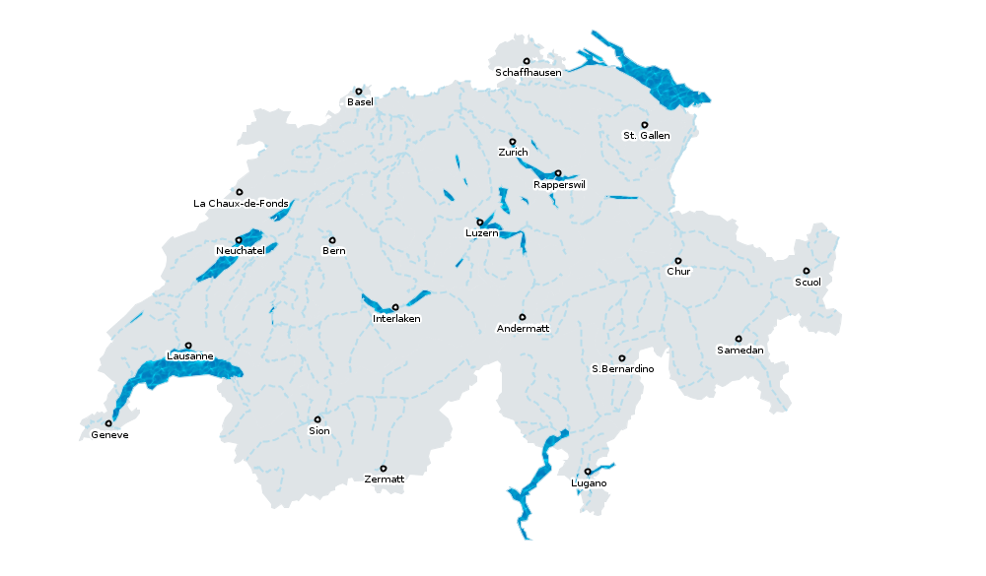
- creation of one more style introducing filtered rule ...
  - we create the NamedStyle “pointFOSSGIS” based on our NamedStyle “pointCities” by adding a filtered Rule element
  - we add a StyleRef for this new style to meteocities <FeatureLayer>
  - we have now two cartographic rules, each applies to a set of features :
    - the first rule applies only to the city of Rapperswil: by adding a filter to this rule (using the <ogc:Filter> syntax), we select Rappelswils' feature by its ID=0 so as to control the rendering engine to apply an ExternalGraphic based PointSymbolizer to that feature only
    - the second rule applies to all other features of the layer: by adding the <ElseFilter/> element to this rule, we select all the other features that have not been selected by another filtered rule (here it means ID <> 0) and this is to control the rendering engine to apply our previous combination of PointSymbolizer/TextSymbolizer to all these other features
  - this logic is not different than the common if...then...else statment in programming
  - we test it as usual !
<FeatureTypeStyle ...>
<Name>pointFOSSGIS</Name>
<Description>
<Title>Discover filtered Rule element</Title>
</Description>
<Rule>
<ogc:Filter>
<ogc:PropertyIsEqualTo>
<ogc:PropertyName>ID</ogc:PropertyName>
<ogc:Literal>0</ogc:Literal>
</ogc:PropertyIsEqualTo>
</ogc:Filter>
<PointSymbolizer>
<Graphic>
<ExternalGraphic>
<OnlineResource xlink:href="images/fossgis_logo.png"/>
<Format>image/png</Format>
</ExternalGraphic>
<AnchorPoint>
<AnchorPointX>0.2</AnchorPointX>
<AnchorPointY>0.4</AnchorPointY>
</AnchorPoint>
</Graphic>
</PointSymbolizer>
</Rule>
<Rule>
<ElseFilter/>
<PointSymbolizer>
<Graphic>
<Mark>
<WellKnownName>circle</WellKnownName>
<Fill>
<SvgParameter name="fill">#FFFFFF</SvgParameter>
</Fill>
<Stroke>
<SvgParameter name="stroke">#000000</SvgParameter>
<SvgParameter name="stroke-width">2</SvgParameter>
</Stroke>
</Mark>
<Size>6</Size>
</Graphic>
</PointSymbolizer>
<TextSymbolizer>
<Label>
<ogc:PropertyName>NAME</ogc:PropertyName>
</Label>
<LabelPlacement>
<PointPlacement>
<Displacement>
<DisplacementX>0</DisplacementX>
<DisplacementY>-10</DisplacementY>
</Displacement>
</PointPlacement>
</LabelPlacement>
<Fill>
<SvgParameter name="fill">#000000</SvgParameter>
</Fill>
</TextSymbolizer>
</Rule>
</FeatureTypeStyle>
- see below the final result you should get ...
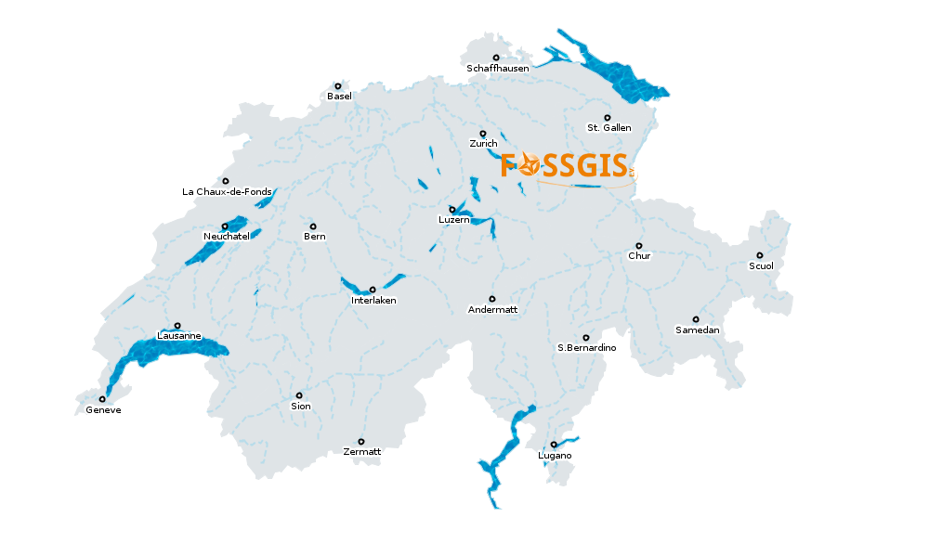

Part II : discovering Symbology Encoging 1.1 further with UserStyles
Preliminary : before going to part II, we need to configure on last thing on our deegree3
- creation of a deegreeWMS configuration ...
  - we create the mywfs.xml file in DEEGREE_WORKSPACE_ROOT/services directory
  - it configure the WFS service so that all the underlying FeatureStore can be queried with EPSG:4326 and EPSG:21781 SRS
  - reload deegree3 from the console and test it by requesting : http://localhost:8080/services/mywfs?service=WFS&request=GetCapabilities
<deegreeWFS xmlns="http://www.deegree.org/services/wfs"
xmlns:xsi="http://www.w3.org/2001/XMLSchema-instance" configVersion="3.2.0"
xsi:schemaLocation="http://www.deegree.org/services/wfs http://schemas.deegree.org/services/wfs/3.2.0/wfs_configuration.xsd">
<QueryCRS>urn:ogc:def:crs:EPSG::4326</QueryCRS>
<QueryCRS>urn:ogc:def:crs:EPSG::21781</QueryCRS>
</deegreeWFS>
SLD/SE Part2
In the following part we will present the UserStyle SLD 1.1 mechanism for client customization while pursueing to discover styling capacities of SE 1.1.
- go to SLD/SE Part2 ...

