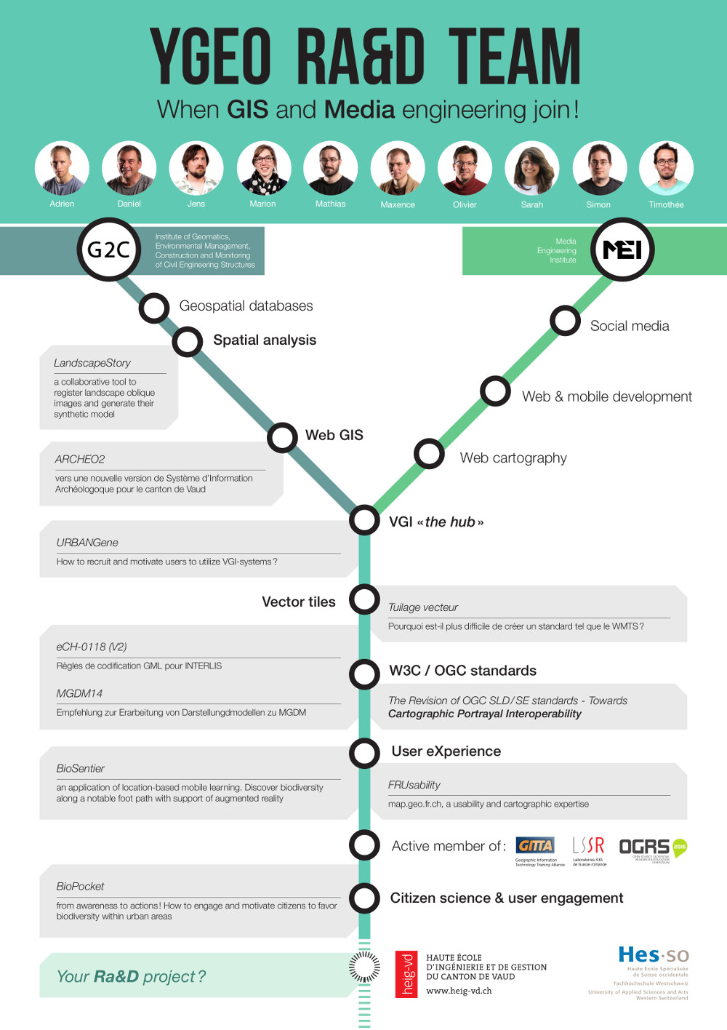
The yGeo team is an initiative from professors concerned by research and education at EC+G and COMEM+ departements (HEIG-VD / University of Applied Sciences Western Switzerland, in Yverdon-les-Bains). They want to put together skills and knowledge to enable the fusion of GIS and Media technologies.
Contacts:
- Pr. ERTZ Olivier - http://contacts.heig-vd.ch/oez
- Pr. INGENSAND Jens - http://contacts.heig-vd.ch/jid

Projects and publications
(... in october) Session about Citizen science and user generated geospatial content (proposal DOI: https://doi.org/10.7287/peerj.preprints.2230v1) OGRS 2016 Open Source Geospatial Research & Education Symposium, OGRS 2016 PeerJ Collection
(... in september) Implementation of tiled vector services: a case study GIScience 2016, Workshop on Spatial Data on the Web
Session biodiversité : projets BioMon, BioSentier, BioPocket LSSR 2016, Journée des Laboratoires SIG de Suisse romande
Tuilage vecteur: Pourquoi est-il plus difficile de créer un standard tel que le WMTS ? GeoSummit 2016, Expo et congrès de la géoinformation
Workshop on Citizen science & VGI GeoSummit 2016, Expo et congrès de la géoinformation
How to recruit and motivate users to utilize VGI systems? (short paper, slides, screencast UrbanGene, screencast Signalez-nous, webapp UrbanGene) AGILE 2016, Conference of the Association of Geographic Information Laboratories in Europe
A 3D georeferencer and viewer to relate landscape pictures with VGI (slides, screencast) AGILE 2016, Conference of the Association of Geographic Information Laboratories in Europe Motivating Citizens to Take Action for Biodiversity Conservation using Geospatial Systems AGILE 2015, Conference of the Association of Geographic Information Laboratories in Europe
The Urbangene project - Experience from a crowdsourced mapping campaign GISTAM 2015, International Conference on Geographical Information Systems Theory, Applications and Management

